**Multimedia & Graphics**

**Class Six**

**Lab 14**

|  |
| --- |
| Lab Objectives:Introduction to Sketchpad |

# IMG_256What is Sketchpad ?

## Sketchpad is an online painting tool.

## royal-blue-wedding-background-design-pngYou can perform various types of design using sketchpad.

# Jump into sketchpad

## Open your web browser and go to

## <https://sketch.io/sketchpad/>

## ফেব্রুয়ারী 5 You will see an user interface like below:

# Introduction to sketchpad toolbox

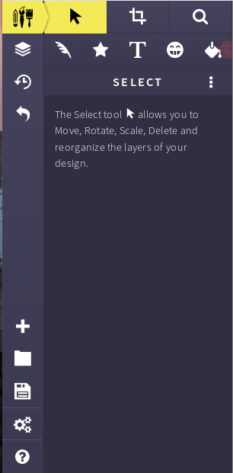

## The left sided bar is the tool bar. You have to use different types of tools for different purpose.

## ফেব্রুয়ারী 5 _21 2 3

## 4 5 6 7 8

## Select Tool

## Crop Tool

## Search Tool

## Brush Tool

## Shape Tool

## Text Tool

## Clip art

## ফেব্রুয়ারী 5 _3Vector Tool

## There are some other icons In bottom left corner.

## + sign denotes opening a new file and serially there are ‘open folder’ button, ‘save or export’ button, ‘setting’ options and at last an user manual.

# Start Painting

When you click on + sign you have to define the canvas size where you will draw your stuffs.

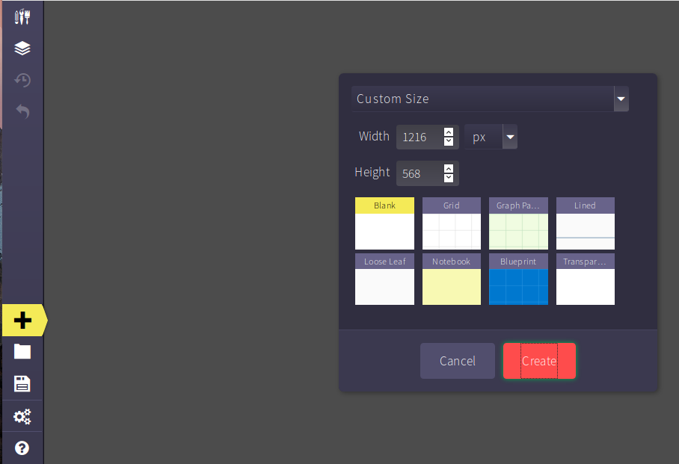

Select the height and width of your canvas and start drawing.

You can use Ctrl + or Ctrl - to zoom in zoom out your canvas.

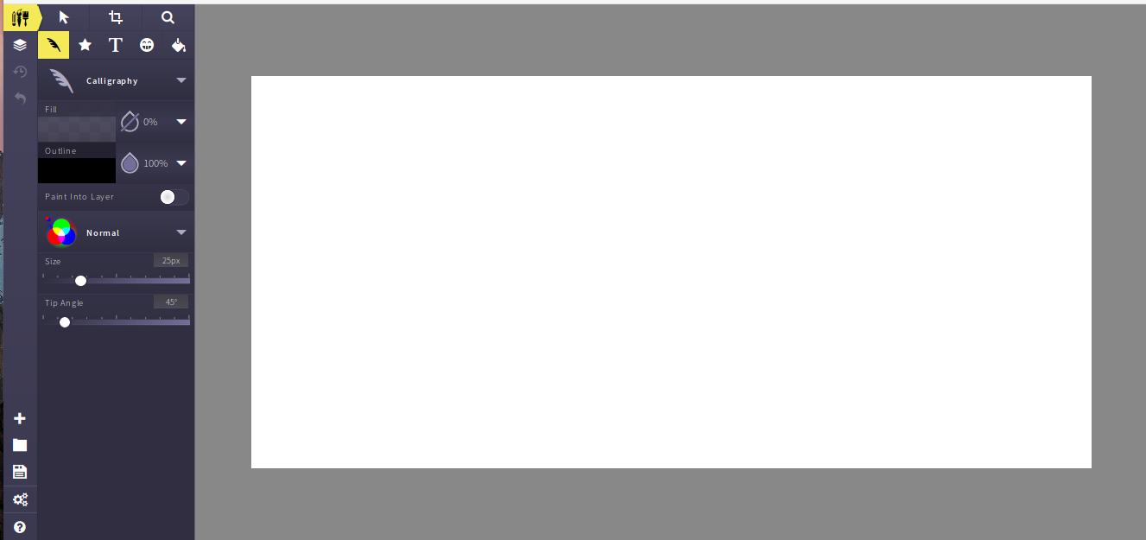

# Brush Tools

You can see a bunch of brushes under brush tools

Tile Brush , Pencil, Calligraphy, Spirograph and etc.

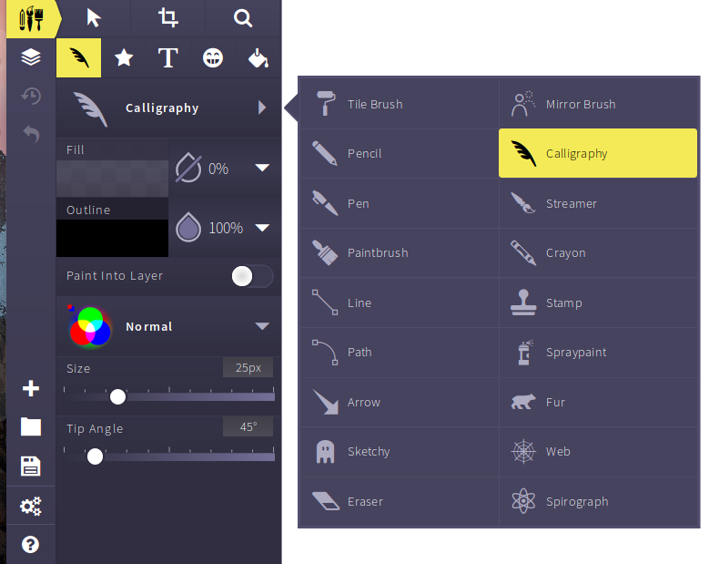

Let’s try. Select brushes one after another and use mouse to draw what you want.

### Tile brush

### ফেব্রুয়ারী 5 _7

You can resize the brush size using size option.

If we enlarge the size of this brush

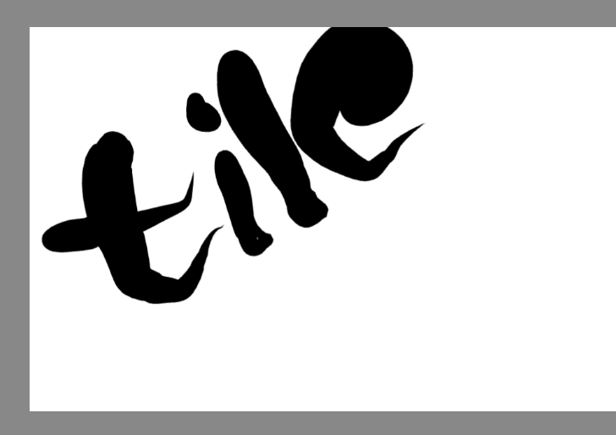

Look at the picture . Size of brush is too bold.

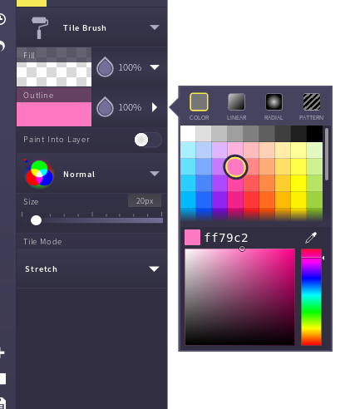

You can color your paint. Click outline, choose any color and draw your paint



Let’s explore about other brushes

### Pencil

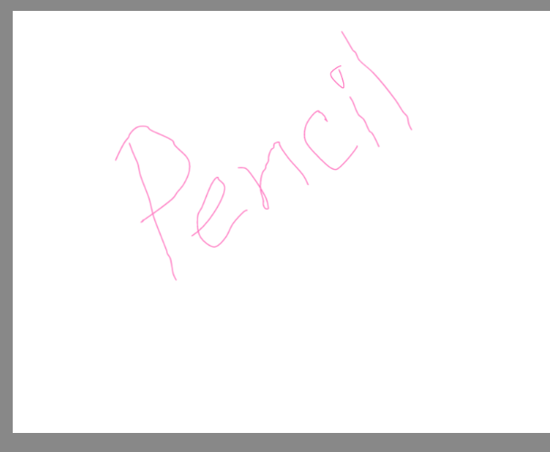

### Paint Brush

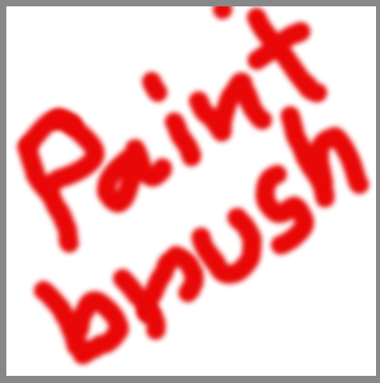

### Web

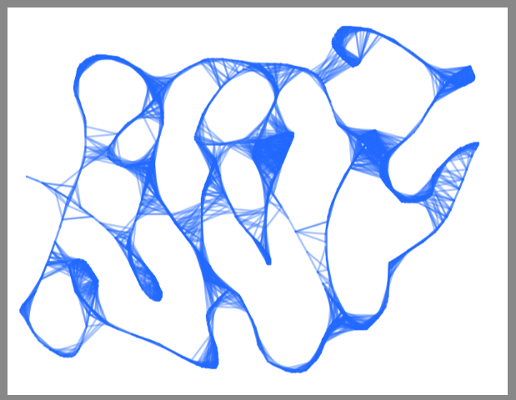

### Calligraphy

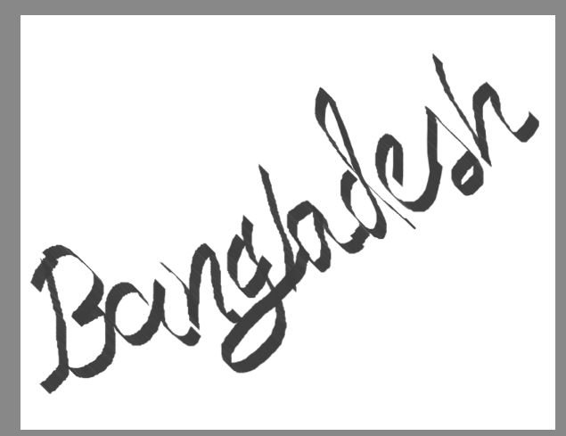

### Fur

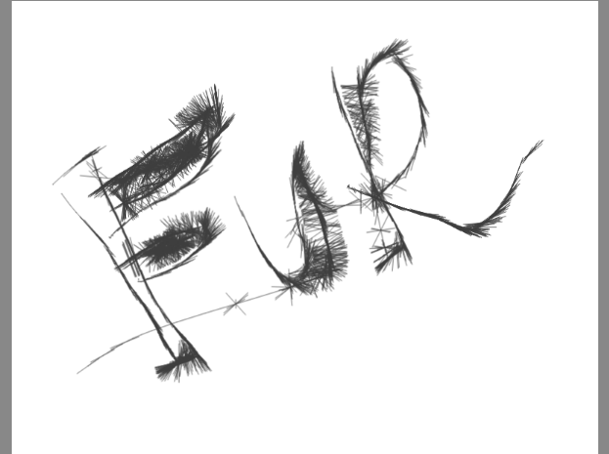

Try every brush in your lab.